ASSIGNMENT 3
Teja Sree (192411211)
CSA1006 – SOFTWARE ENGINEERING
Problem 1: Full-Stack Web App Development for an E-Commerce Dashboard
Scenario:
You are part of a development team building a full stack e-commerce analytics dashboard.
The front end must be built in React, the backend will use Node.js/Express, and the data must be fetched from an API in real time. Marketing teams want interactive charts, while management demands fast loading time and clean UI. Cross-functional Git workflows must be followed, and code reviews are mandatory.
Task:
Design a full-stack solution integrating React frontend + API backend, plan the Git branching strategy, propose a CI flow, and describe how components will interact.
Deliverables:
• System architecture diagram (React → API → Database)
• Git branching strategy (Git Flow or Feature Branching)
•Explanation of API data flow
• Example pull request review checklist
Reasoning:
This scenario mirrors real-world full-stack application development, teaching students to combine UI, API logic, Git collaboration, and clean workflows.

Introduction
StylishMart is a full-stack e-commerce web application developed to provide users with a simple, responsive, and secure online shopping experience. The application enables customers to browse products, search by category, manage their shopping cart, place orders, and view their profile information through an intuitive interface. The frontend is built using React, ensuring a fast and interactive user experience, while the backend APIs communicate with a PostgreSQL database (Supabase) to store and retrieve user profiles and order details. The application follows a modular architecture, making it scalable
, maintainable, and suitable for real-world e-commerce scenarios.
About the Project – StylishMart
StylishMart is a modern full-stack e-commerce web application designed to provide customers with a convenient and seamless online shopping experience. The platform allows users to browse products, search items by category, add products to the shopping cart, manage their user profile, and complete the checkout process through a simple and responsive interface.
The application is developed using React for the frontend, which provides a fast, interactive, and user-friendly experience. The backend services communicate with a PostgreSQL database (Supabase) through REST APIs to manage user profiles, orders, and other application data efficiently. The application follows a modular architecture, enabling easy maintenance, scalability, and future feature enhancements.
StylishMart includes key e-commerce functionalities such as product browsing, search and filtering, cart management, order placement, secure user authentication, and profile management. The responsive design ensures that the website works smoothly across desktops, tablets, and mobile devices.
Overall, StylishMart demonstrates the implementation of modern full-stack web development concepts by integrating an attractive frontend, backend API services, and a cloud-based database to deliver a reliable, scalable, and user-friendly online shopping platform.
Software Used
Software/Tool | Purpose
React | Frontend user interface development
JavaScript | Client-side programming
HTML5 | Web page structure
CSS3 | Styling and responsive design
Supabase | Backend services and REST APIs
PostgreSQL | Database for storing application data
Git | Version control and source code management
GitHub | Code repository and collaboration
Google Chrome | Application testing and debugging
Chrome Developer Tools | API testing and debugging
Lovable | Application development and deployment platform

Conclusion
The StylishMart project successfully demonstrates the development of a full-stack e-commerce application using modern web technologies. It integrates a responsive React frontend with backend API services and a PostgreSQL database to manage products, user profiles, and customer orders efficiently. The application follows a structured development workflow using Git for version control and supports scalable architecture for future enhancements. Overall, the project provides a secure, user-friendly, and efficient online shopping platform while demonstrating practical full-stack web development concepts.
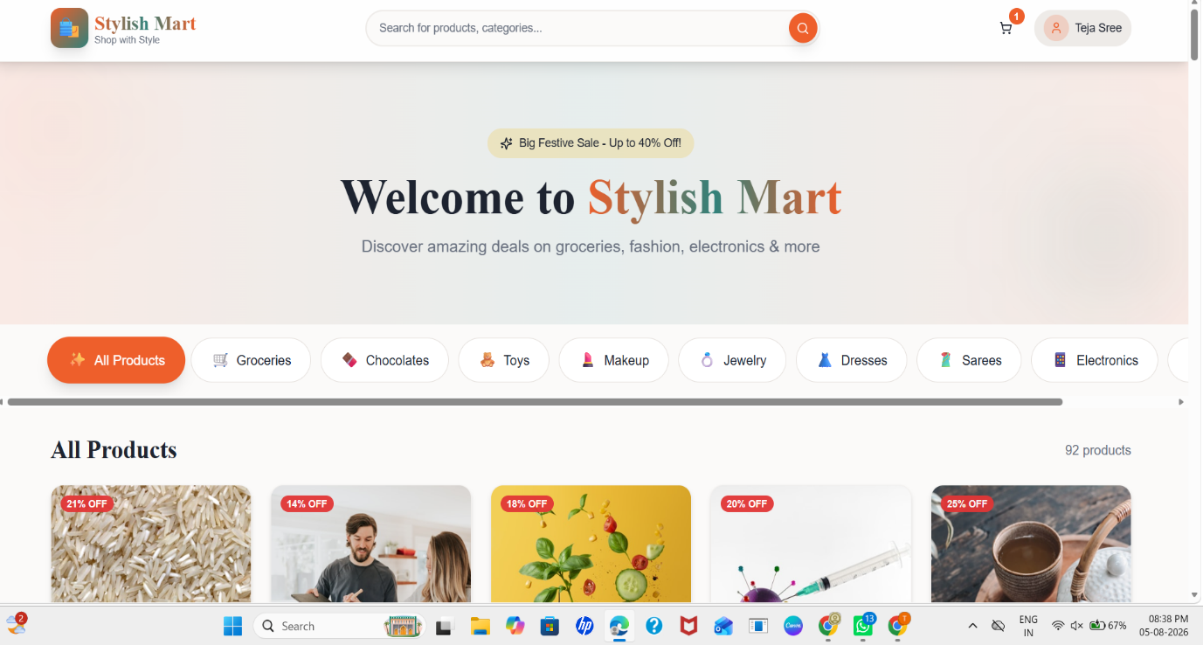
OUTPUT:
